Git and GitHub Challenge Task
- Resolve Merge Conflicts
  - Create a merge conflict intentionally (two users editing the same line).
  - Resolve the conflict and push the changes.
    - In Branch-Hotfix-> created a file money and commit changes done.
    - Switched to Master branch and created a file money and commit changes done.
    - In both the branches, the file money has the same content, so we got an error while merging the branches.
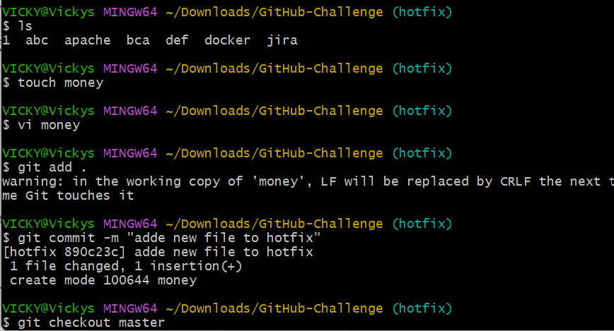
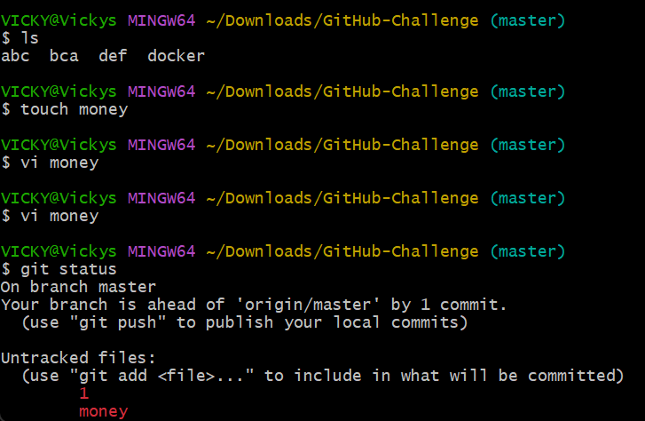
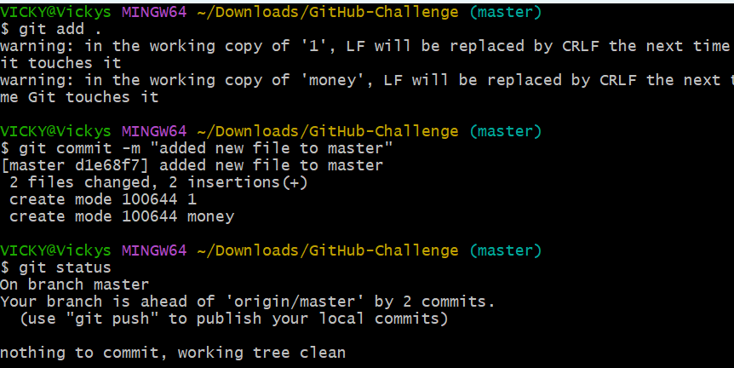
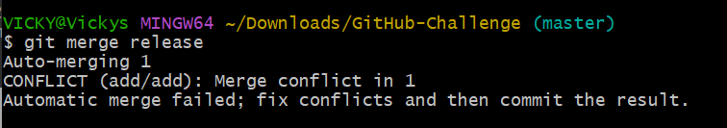
    - Updated the content in master branch in the file “money”
    - Changed the content from Hello superman to hi boys.
    - Once modified pushed to commit and merged the branches from master to hotfix.
    - Success merging is successful.
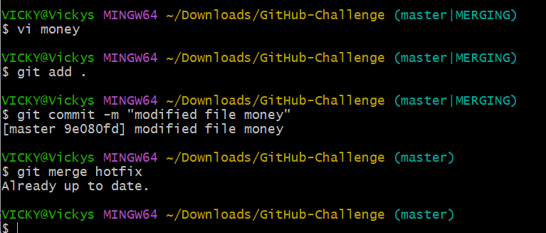

- Recover Deleted Branch
  - Delete a local branch and then recover it using the reflog.
    - Steps- Created a branch “admin” and verified the branch present by command- git branch –list.
    - Switched the branch to admin from master.
    - Created a file maker and commit performed.
    - Copied the commit id and switched to master branch.
    - Deleted the admin branch by command- git branch -D admin.
    - By using command- git reflog; we noticed all the commit are present.
    - Copied the commit ID from admin branch- file created and used command- git checkout -b admin commit ID.
    - Now the deleted branch is recovered.
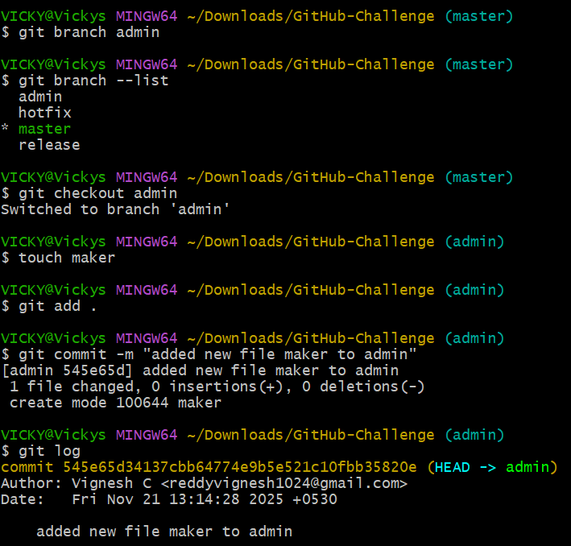
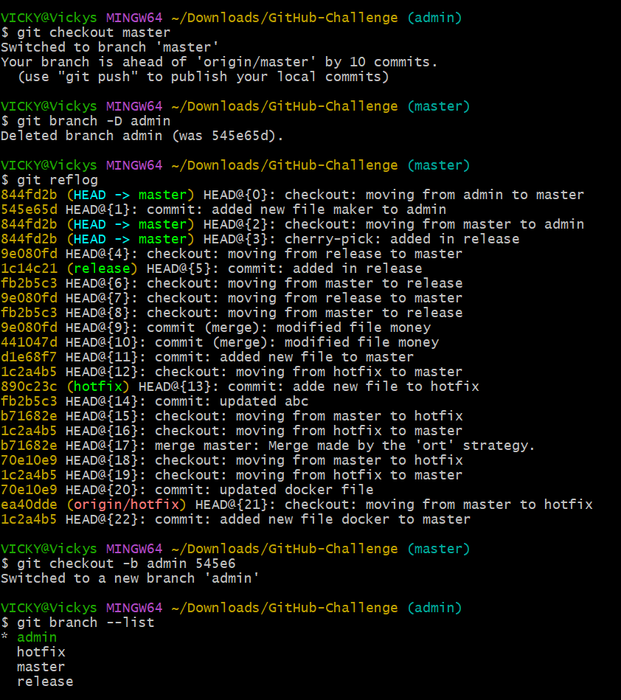

- Undo Wrong Push
  - Push a wrong commit to GitHub, then undo it without losing history.
    - Created a file added the file commit file completed pushed to central repositorysuccess
    - Using git revert commit id I was able to revert the commit back.

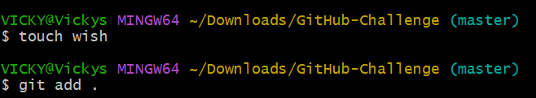
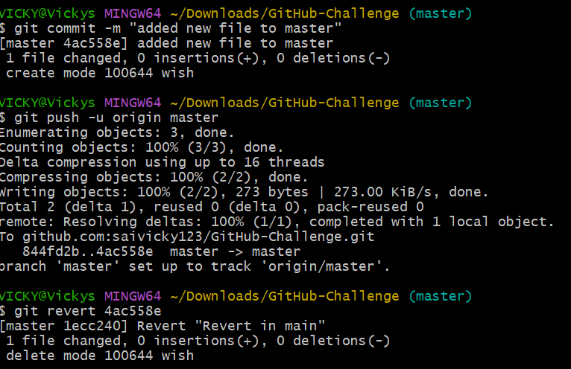
- Amend a Commit
  - Make a commit, then add a missing file to it using git commit --amend.
    - Once the file is commit complete. Then we changed the name (from “revert in main” to “missing file” of commit using git commit –amend.
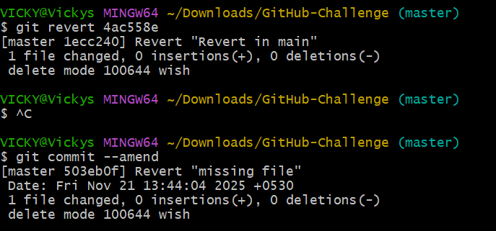
- Cherry-pick a Commit
  - Take a specific commit from one branch and apply it to another branch.
    - Created a file in release branch and commit performed.
    - Once Commit ID generated by command- git log
    - Copied the command and switched to master branch.
    - Used command- git cherry-pick (commit id pasted)
    - Success- the commit id is branched to master branch.
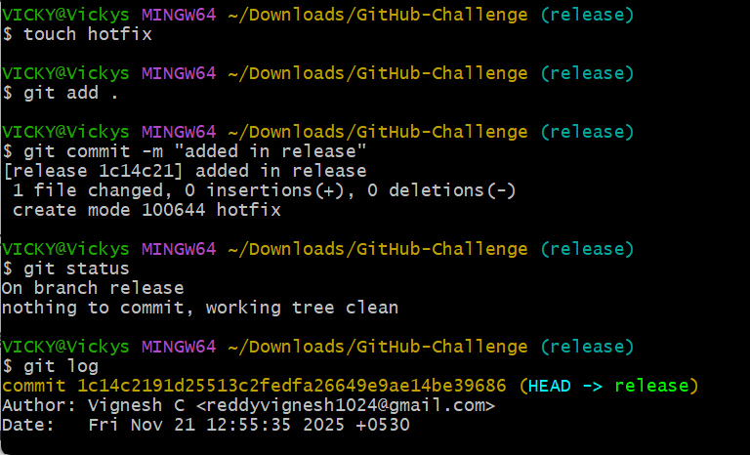
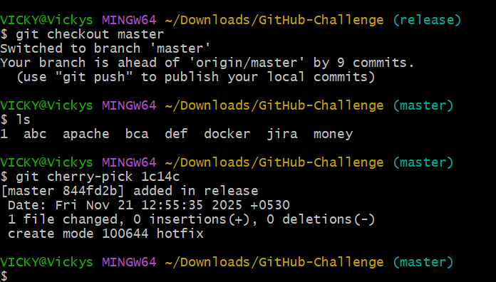

- Interactive Rebase
  - Reorder and squash multiple commits into a single clean commit.
    - Using- git log- verified the commit present in the branch.
    - Using command- git rebase -I HEAD~3, I picked the first 3 commit and edited in the vi.
    - Rearranged 3 commit from top to bottom and picked the 1st commit “pick” and the rest 2 commit as “squash”.
    - Successfully the last 2 commit has been merged to the 1st commit.
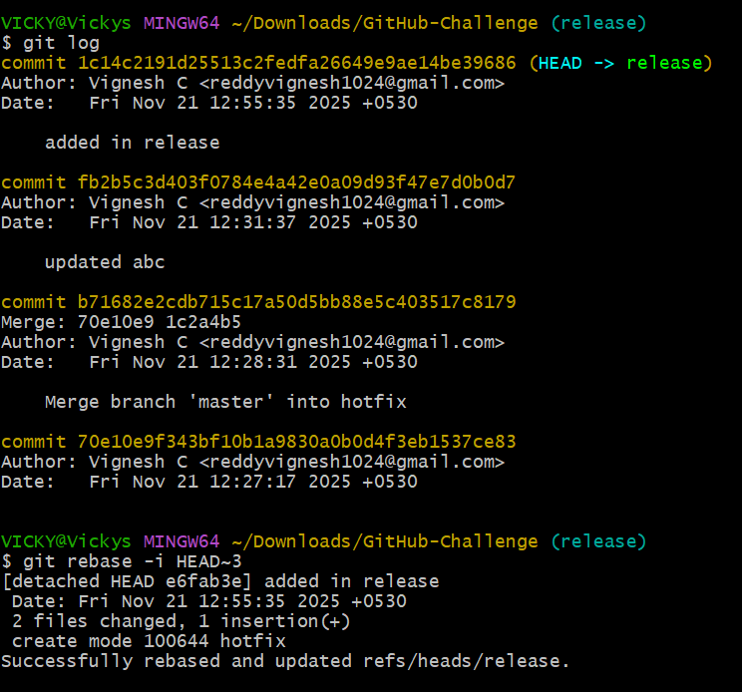
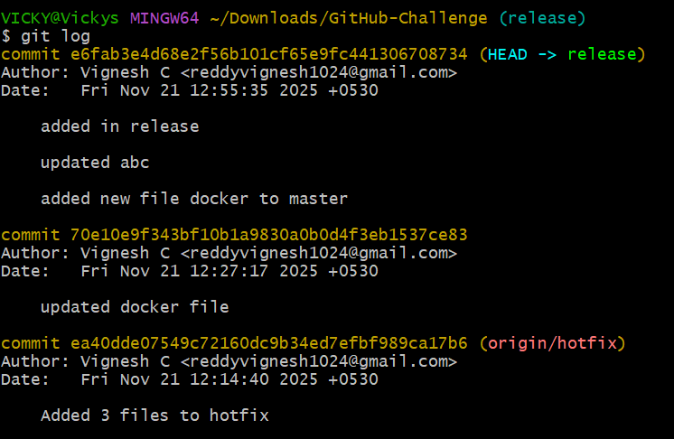

- Tagging & Release
  - Create a version tag (v1.0), push it to GitHub, then delete and restore it.
- Created a git tag by using command- git tag -a v1.0 commit -m “message”.
- a is annotated tag and m is message for the tag.
- Using command- git tag, we can verify if the tag is added.
- Using command- git log, verified if the tag is added to the commit.
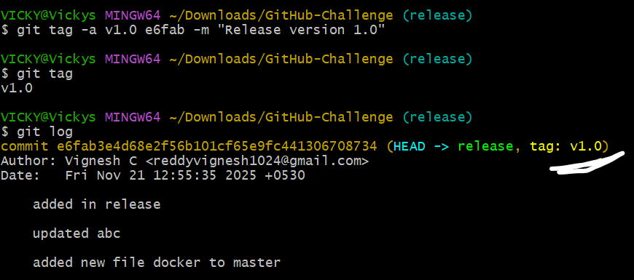

- Once tag is added to the commit, we need to push to the repo- command- git push origin (version)
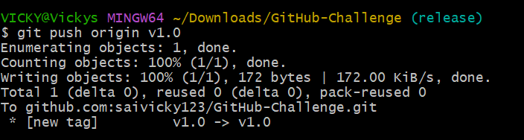
- Verified in the repo and tag is pushed to GitHub.
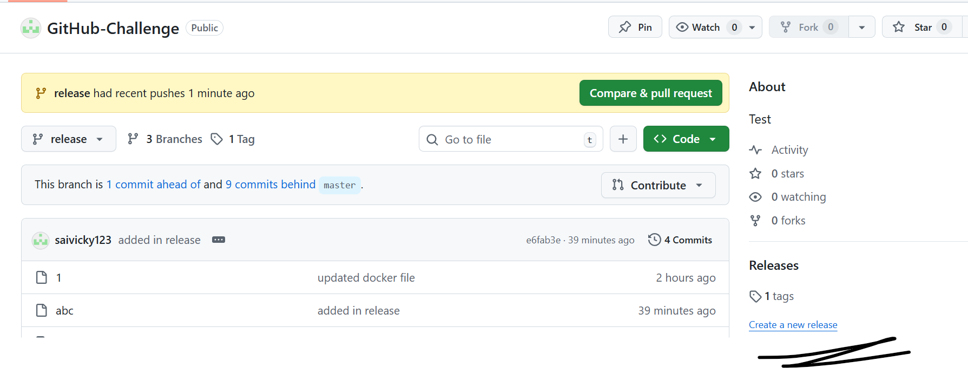
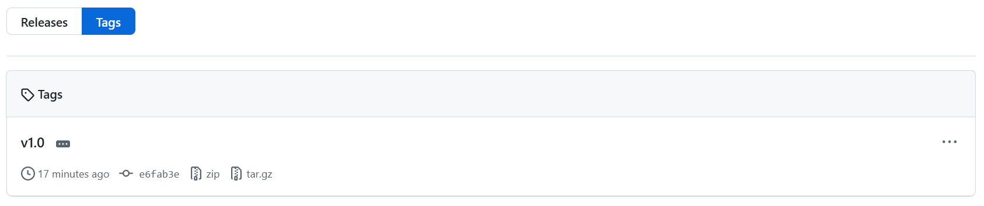
- Now we are deleting the tag by using command- git tag -d (version)
- Again, we are restoring by the same command which we used for creation- git tag – a v1.0 commit -m “message”
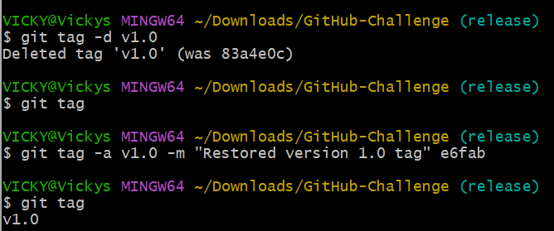

- Reset vs Revert Challenge
  - Demonstrate the difference between git reset --hard and git revert in a repo.
    - Using command- git –oneline, I verified the commit logs present in my master branch.
    - Command- git reset --hard (503eb0f) to remove the head commit.
    - Head commit (09d2c7f) has been deleted.
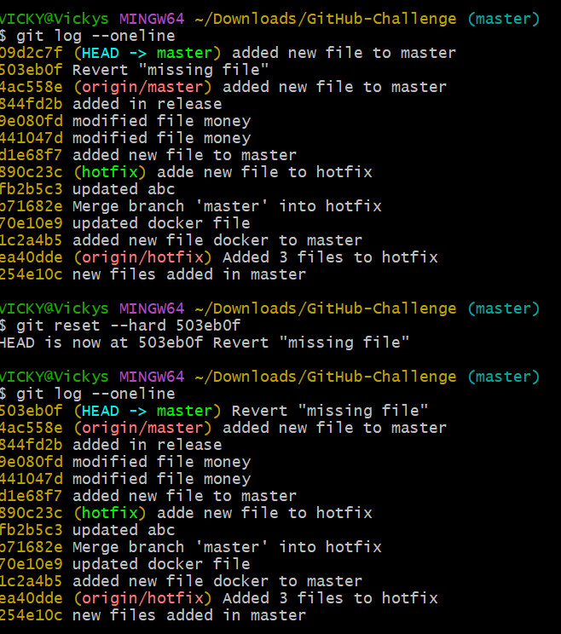

    - Git revert
    - Created a file addedcommit done
    - Verified the newly commit file by command- git log --online.
    - Git revert 9e4cdfd and revert file added in Head.
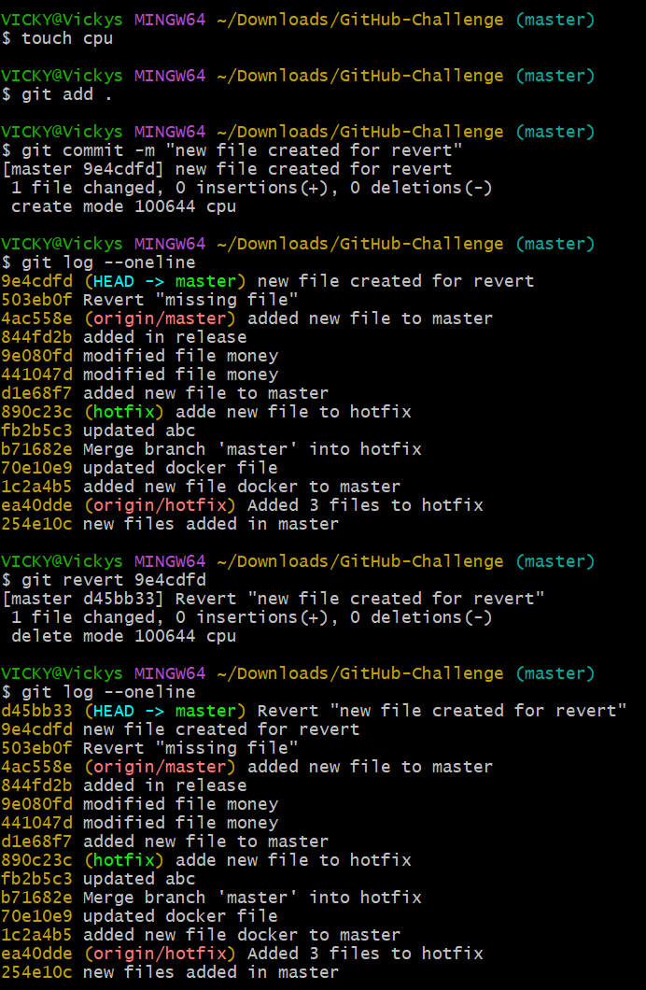
- Detached HEAD Challenge
  - Checkout a specific commit (detached HEAD state) and create a new branch from it.
    - Using command git log --oneline, we verified the commits.
    - Now, we need to use command- git checkout d45bb33 (Head commit).
    - Now the git branch will be checked out to the commit branch.
    - By verifying in git branch, now we can see the commit is Detached at d45bb33.
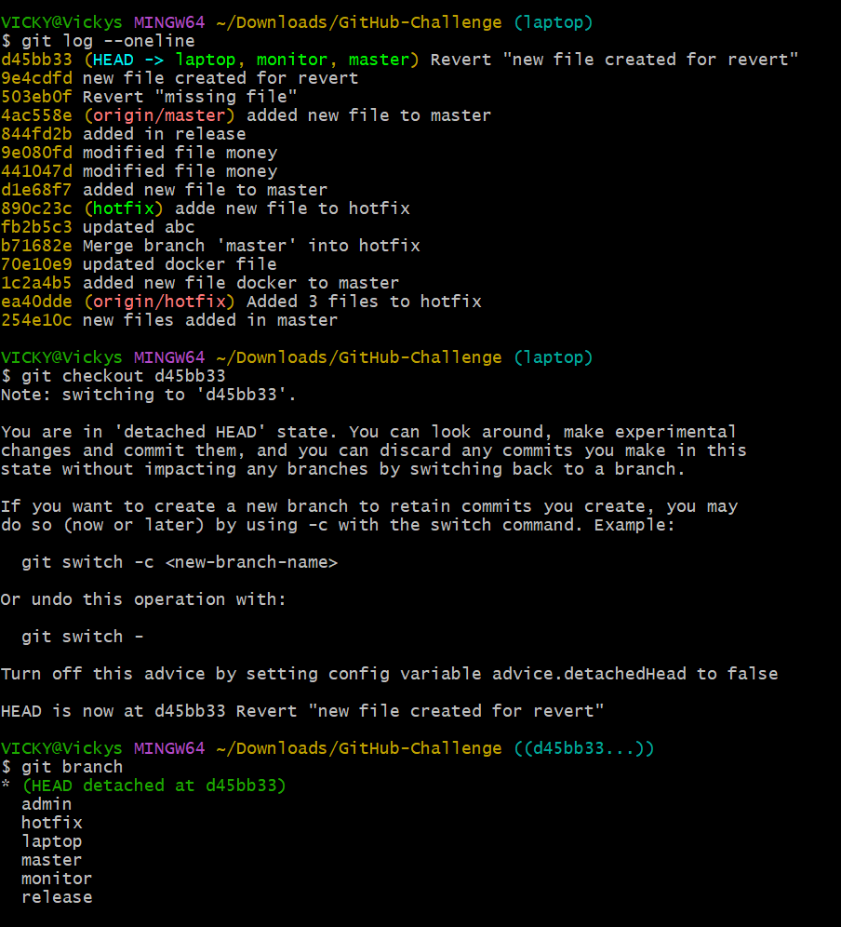
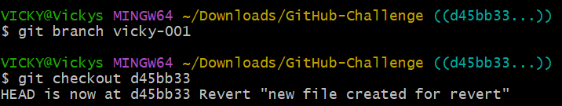
- Squash Merge vs Rebase Merge
  - Show the difference between squash merge and rebase merge with evidence.
    - Created a new branch called -develop.
    - Created two files and two different commits.
    - Using command- git log -- online -- graph -- decorate -n 5, we can select only 5 commits.
    - Then we switched back to Master branch
    - Using command- git merge -- squash develop, we can commit all commits to one commit. Now only one commit appears to be on main.
    - Now the final step is to commit- git commit -m “Squashed develop”
    - Success- now the Squash merge is complete
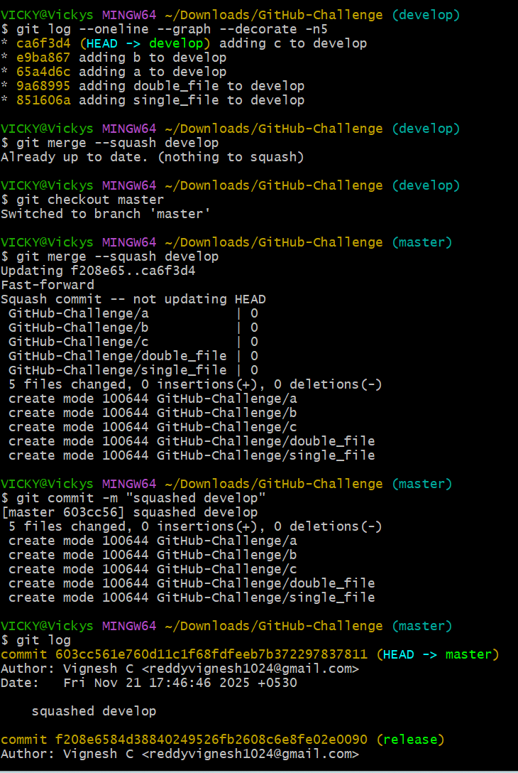

Rebase Merge:
    - For git rebase merging, the following process is to be followed.
    - Command- git reset – hard HEAD~1- to make second top commit to Head.
    - Git log confirms the second commit is at Head now.
    - Command- git rebase master will feature on to main branch.
    - Now, its time to checkout to master branch and merge both branches.
    - Success, now the commits are separated and they are into their own.

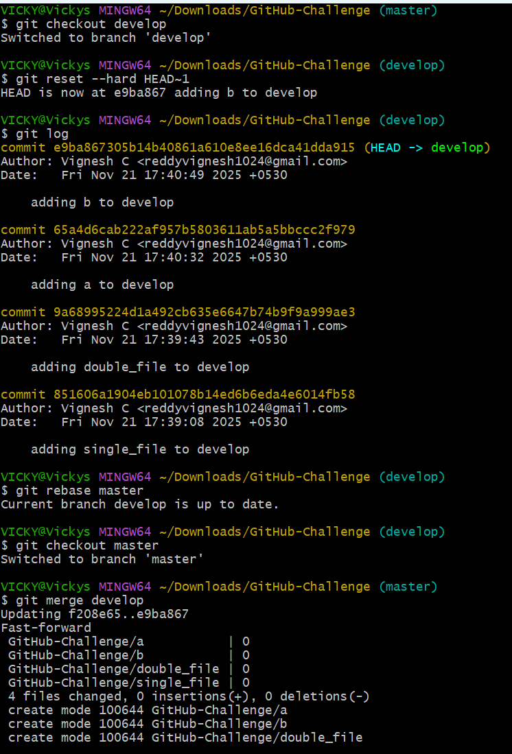
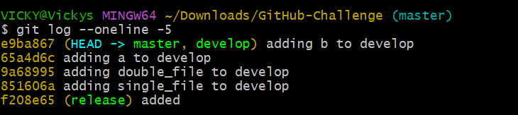

  - Squash merge:
    - Combines all commits into one commit
    - History becomes clean
    - Looks like a single change

  - Rebase merge:
    - Replays commits one-by-one
    - Produces all original commits on main
    - History is linear and detailed

- Fork & Pull Request Workflow
  - Fork a repo, make a change, and submit a pull request to the original repo.
    - Forked with Lalitha in repo with a link.
    - Created a name and repo is active with Lalitha
    - In Git, cloned repo to local
    - Made a change using Vi and file.
    - Pushed the updated changes to GitHub
    - Success.
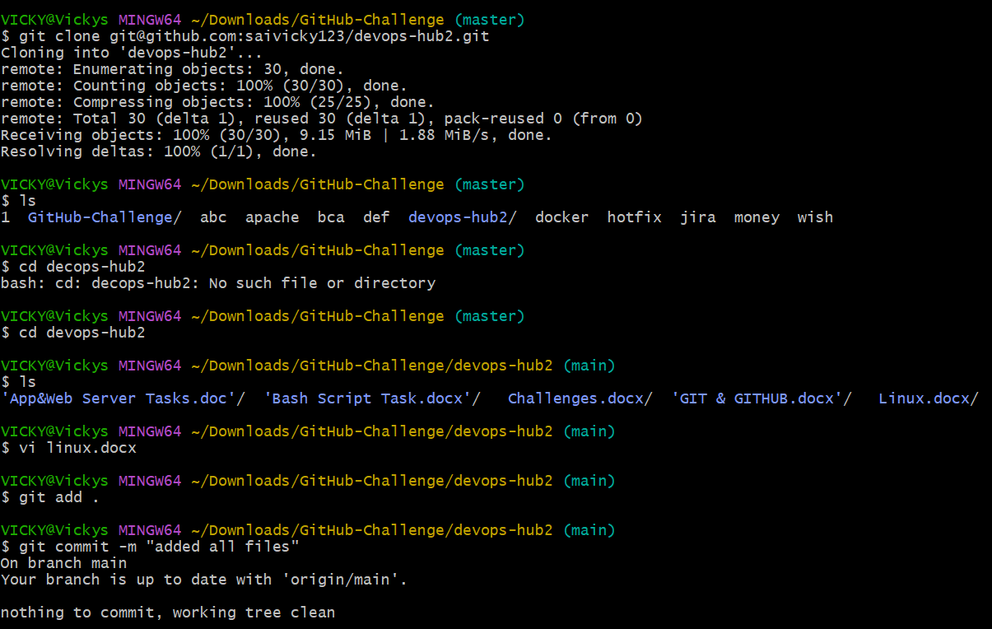
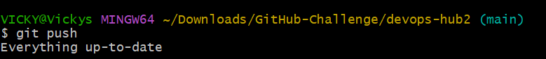
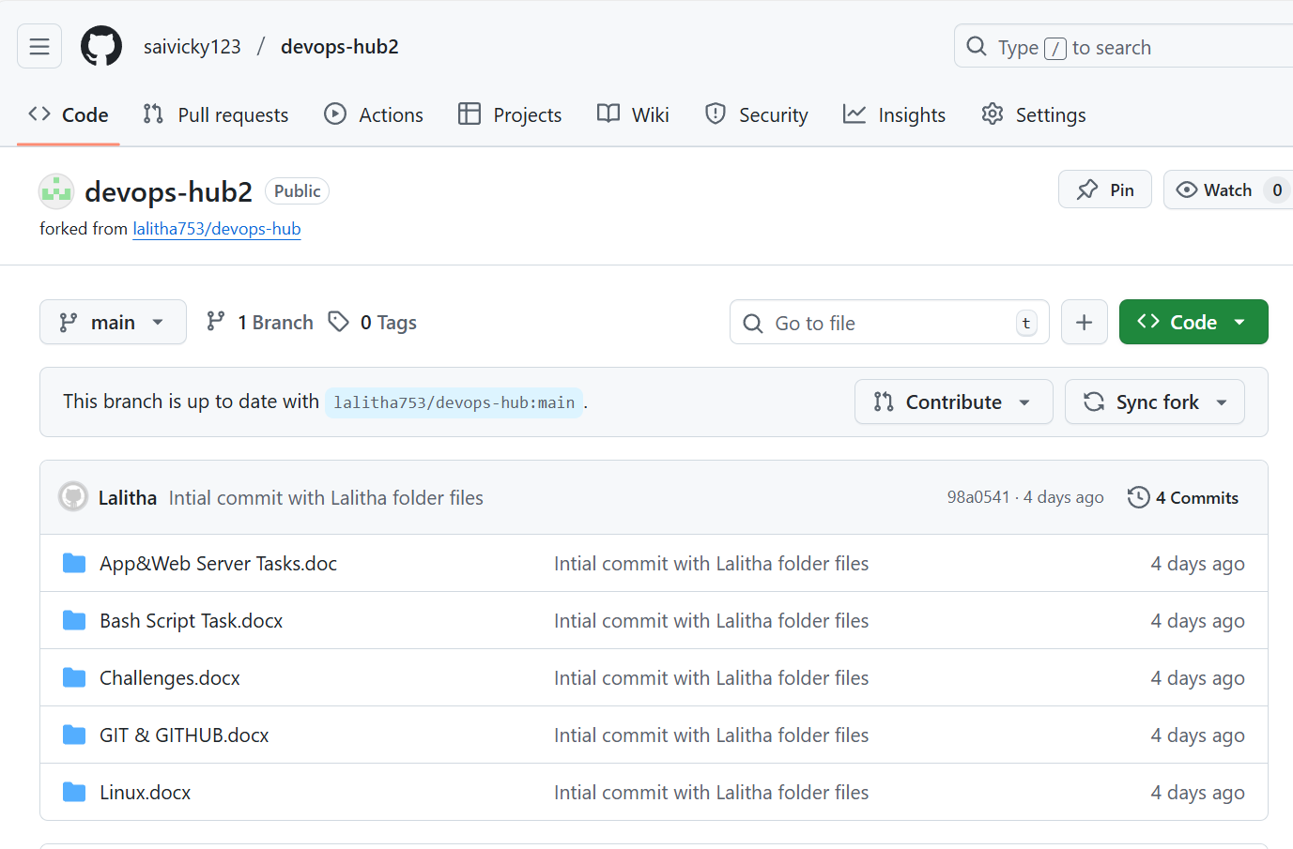

- Recover Lost Commit
  - Commit something, reset hard, and then recover it using git reflog
    - Added a new file git add . git commit done

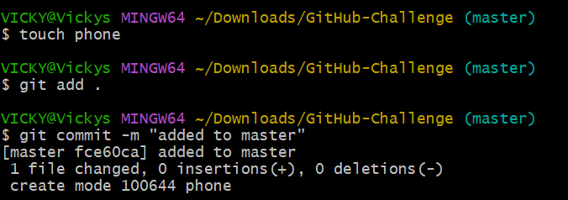

- Command- git log –oneline to verify the commits in oneline.
- Command- git reset –hard HEAD~1 – this will remove the head commit.
- Now to recover, use command- git reflog
- Command- git reflog will show us the information record.
- To recover the deleted commit, we copied the commit ID.
- Now the final step is to – git checkout (commit ID)
- To verify- command- git log –oneline.
- We can see the commit is recovered to Head.
